S&T Greek Life Management Tool
Manual for Chapter Admins

Table of Contents

Chapters Tab ............................................................................................................................. 3
Chapter Capacity ..................................................................................................................... 3
New Member Bid .................................................................................................................... 4
Returning Offers ...................................................................................................................... 5
Member Management .............................................................................................................. 6
Request for Inactive ................................................................................................................. 7
Search Member........................................................................................................................ 8
Members Tab ............................................................................................................................ 8
Student Member ...................................................................................................................... 8
Reports tab ................................................................................................................................ 9
Chapter Reports ....................................................................................................................... 9
Member Reports (Under Construction) .................................................................................. 10
New Member and Returning Member Bid Confirmation ..................................................... 11
Process for New Members and Returning Members receiving bids ........................................ 11

Chapter’s Tab

Chapter Capacity
This process is to set the capacity of your chapter house. This must be done prior to sending out new member bids.
- Hover over the Chapters tab>click on Chapter Capacity, this will pull up a new screen
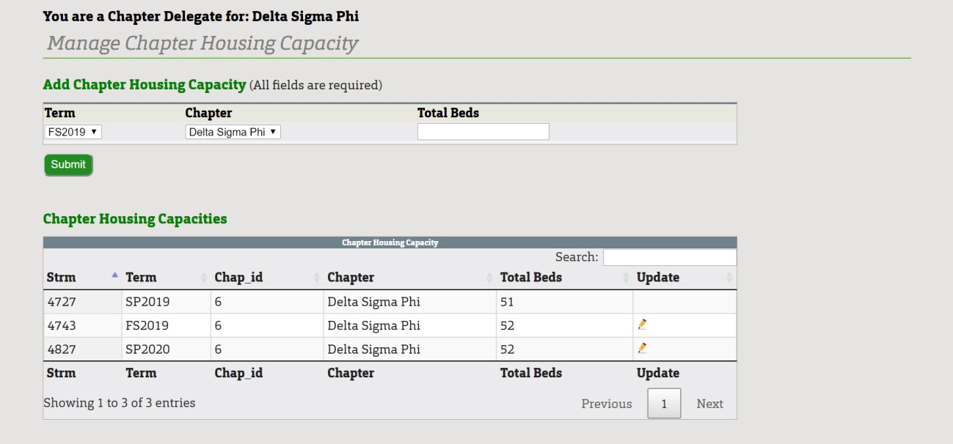
- Select from the Term drop down and Chapter drop down the appropriate selections
- Manually enter the number of Total Beds for that semester for your specific house • Click Submit
- To edit the amount click the pencil icon in table next to your specific chapter and manually enter the number of Total Beds again then click Submit

New Member Bid
- Hover over the click on New Member Bid, this will pull up a new screen
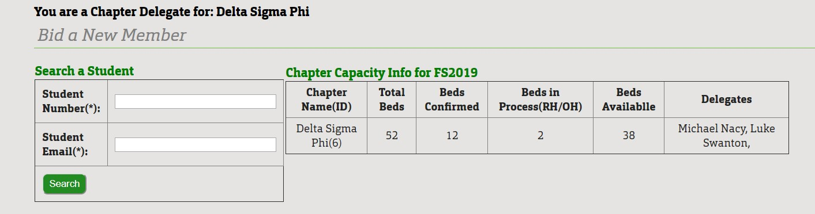
- Enter the Student’s Number (ID) and Email in the appropriate boxes, click search o Note that the email needs to end in @mst.edu NOT @umsystem.edu
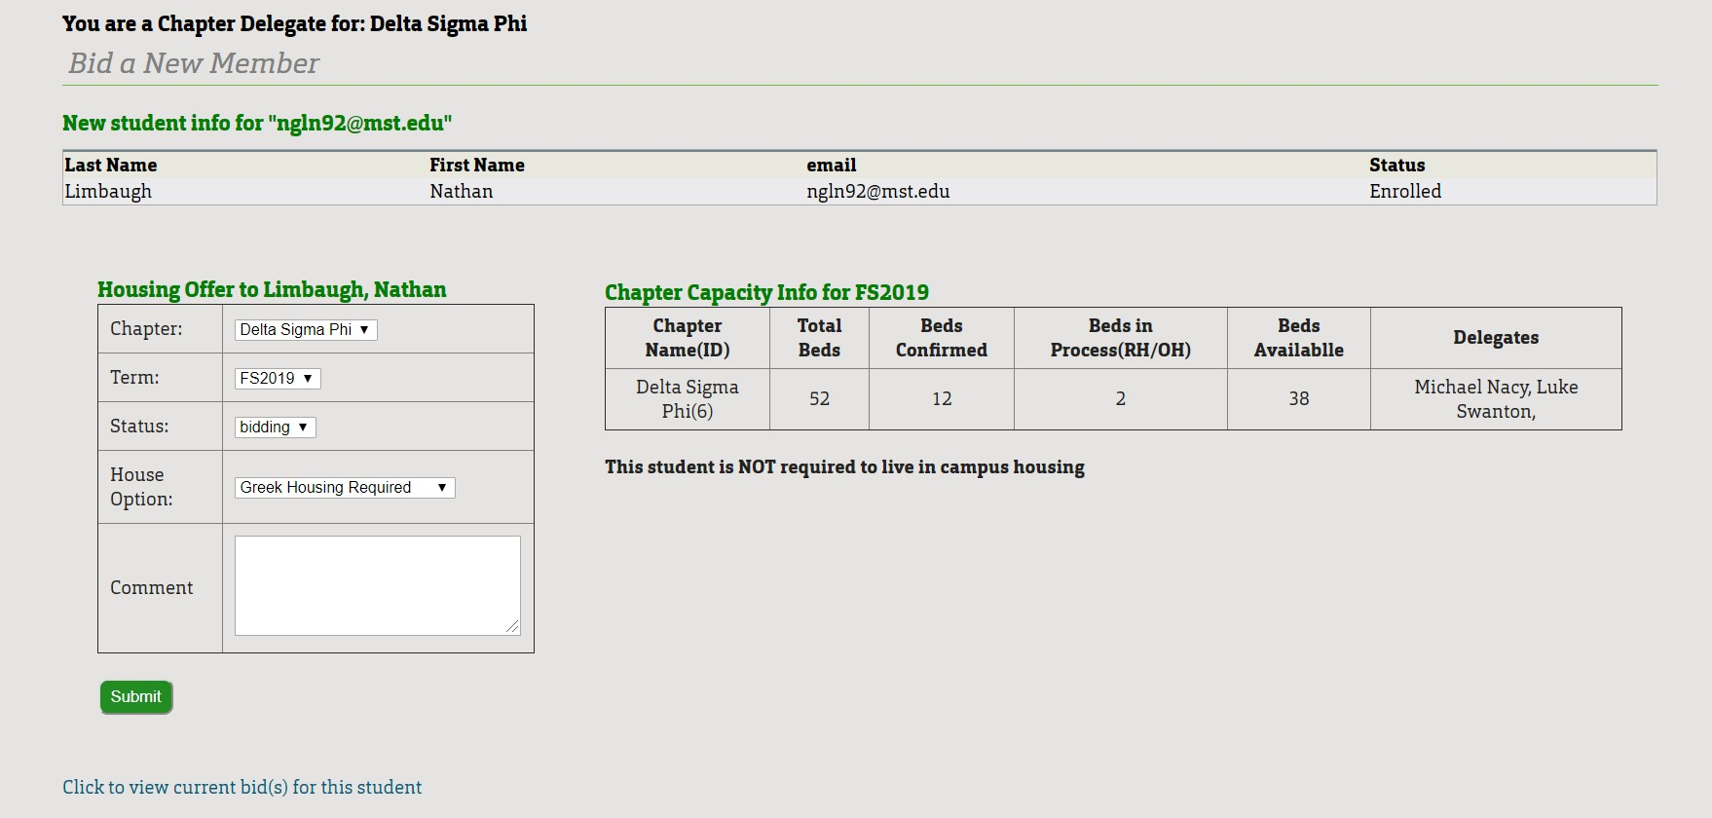
- Ensure that both the Chapter and the Term are correct
- Ensure that the Status is bidding
- Select the appropriate House Option from the drop down o Options include required, optional, or unavailable
o Note to the right there will be a message declaring if student is required to live in on-campus housing or not
- You may leave a note in the comment section if additional comments need to be made • Click Submit
- Once a member has accepted your offer, you can view their response or see who has completed the process at Chapters>Member Management

Returning Offers
- Hover over the click on Returning Offers, this will pull up a new screen
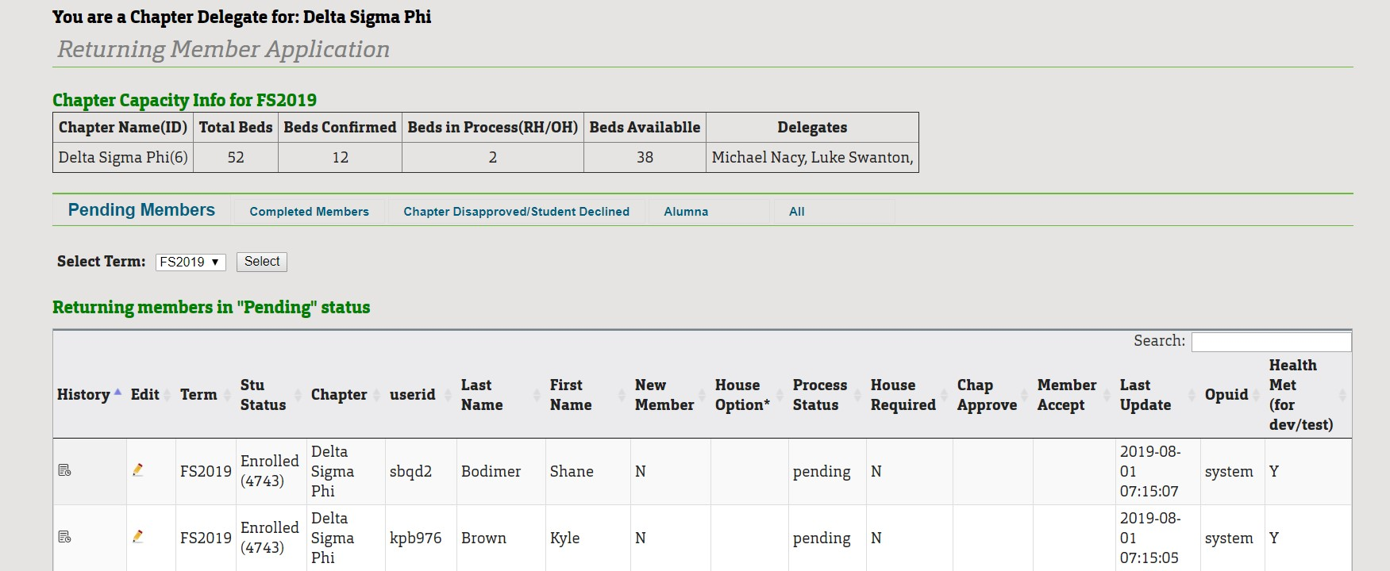
- On each individual name there will be a pencil under the edit column, click on the pencil and a pop up screen should appear
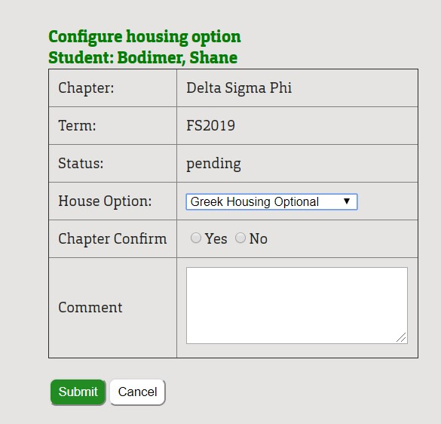
- Select the drop down for the correct House Option, specify what kind of housing o Options include required, optional, or unavailable
- Confirm if the student is still living in the house by selecting the appropriate radio button
- Additional comments can be put in the comments section, then click Submit • The student will be sent an email

Member Management
- Hover over the click on Member Management, this will pull up a new screen
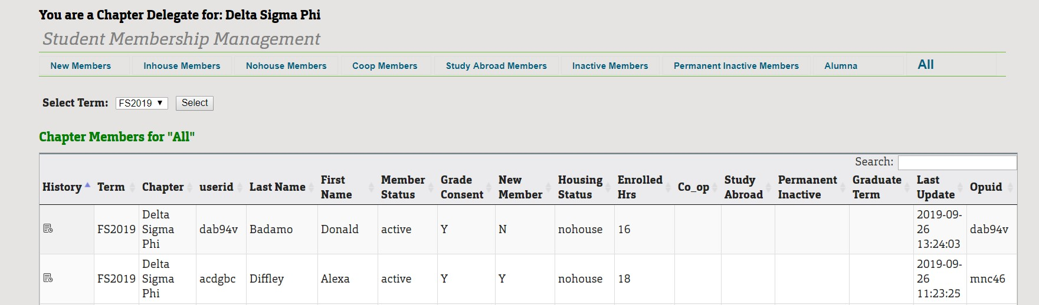
- Select the appropriate term from the drop down, click Select and a table should appear
- Admin can sort members by clicking blue labels at the top underneath the header, Student
Membership Management (ex. New members, Inhouse, etc.)

- The table will then show the information regarding Chapter, User ID, Last Name, First Name, Member Status, Grade Consent, New Member or not, Housing Status, Enrolled
Hrs, Co-op, Study Abroad, Permanent Inactive, Graduate Term, Last Updated, and Opuid)
- If you scroll down to bottom you can download the member list by clicking the Download Member List button

Request for Inactive
- Hover over the click on Request for Inactive, this will pull up a new screen
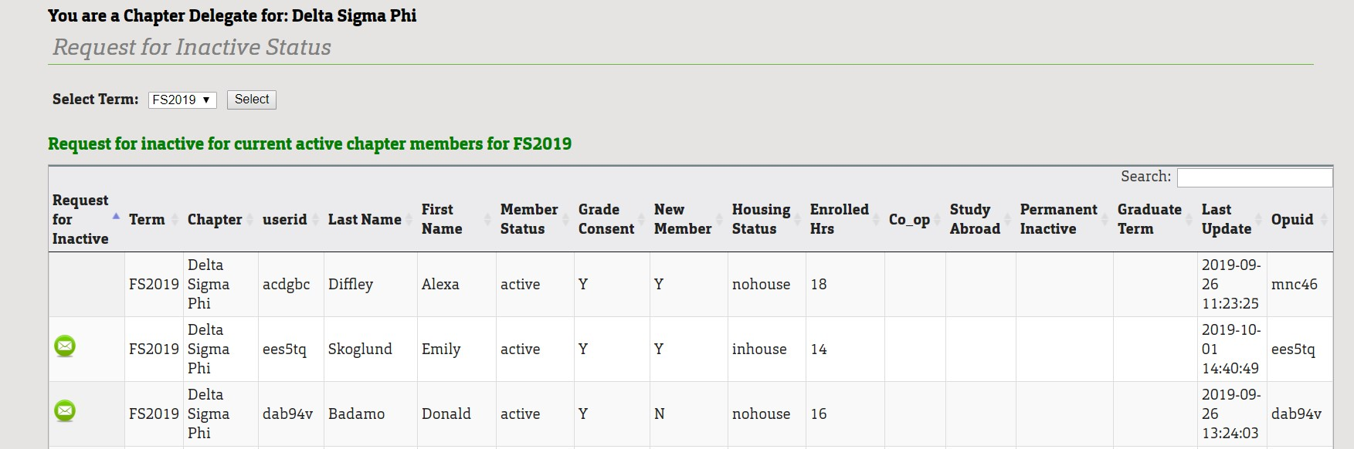
- Select from the drop down for which Term, click Select, a table will display below • In the table select the green email circle, a pop up box will appear
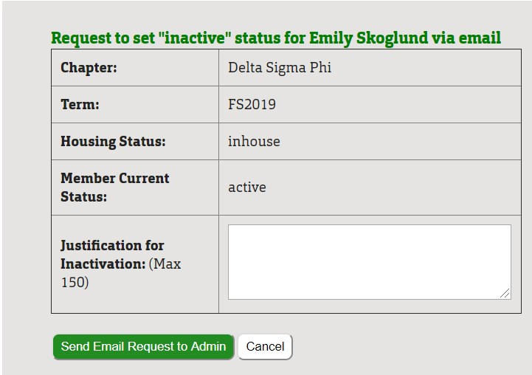

- Type your Reasoning for Request and click Send Email Request to Admin

Search Member
- Hover over the click on Search Member, this will pull up a new screen
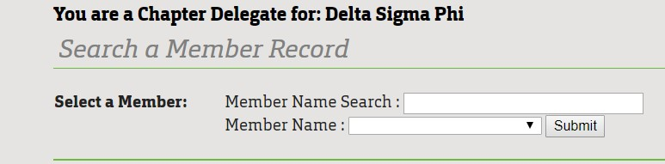
- Search by student’s last name in the first field and then the name should populate in the drop down box below, click Submit
- The information will populate in a table below

Members

Student Member
- Hover over the Members tab>click on Student Member, this will pull up a new screen
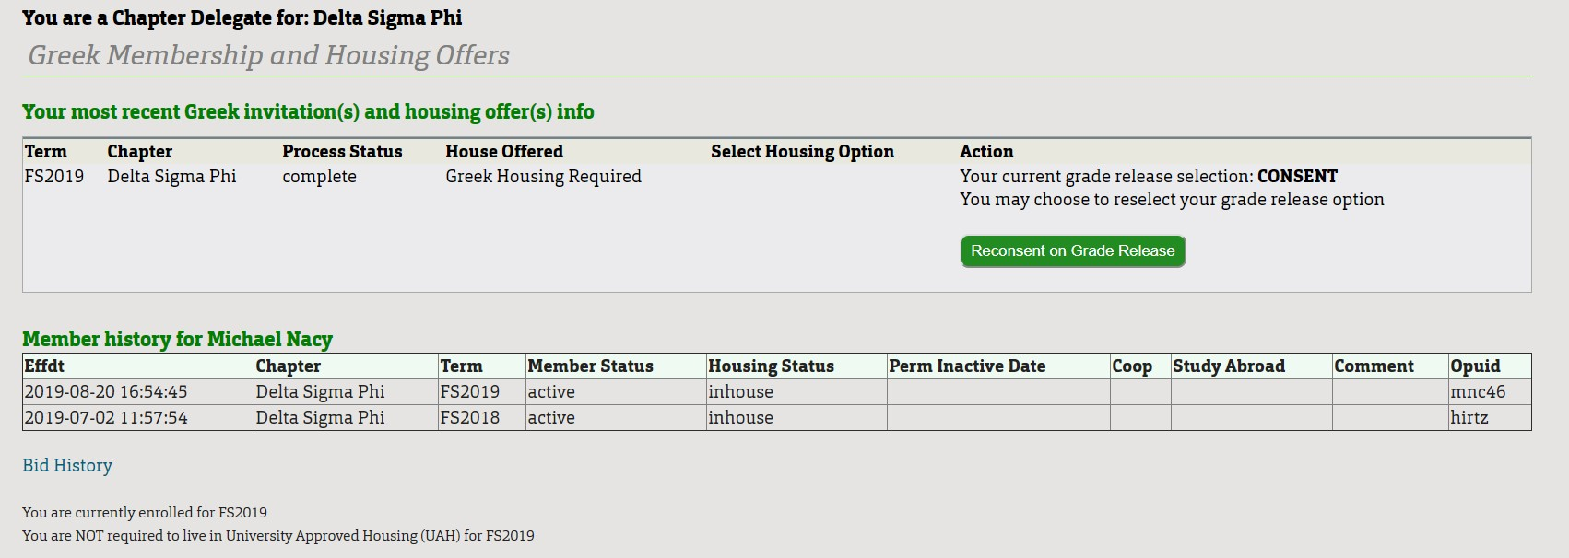
- Click on re-consent on the green grade release button
- Read the Greek Grade Release and click I Consent or I Do Not Consent, then click
Submit o Note: at the top students should see their current grade release selection and the selection can be updated at any time should they change their mind

Reports

Chapter Reports
- Hover over the Reports tab>click on Chapter Reports, this will pull up a new screen
- Two blue options should appear including Membership Roster Report & Individual Grade Report
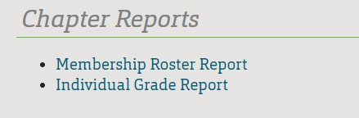
- Click on Member Roster Report
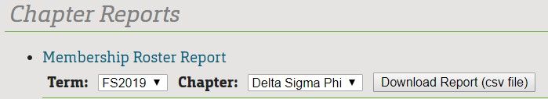
    - Select appropriate term and chapter from the drop down boxes
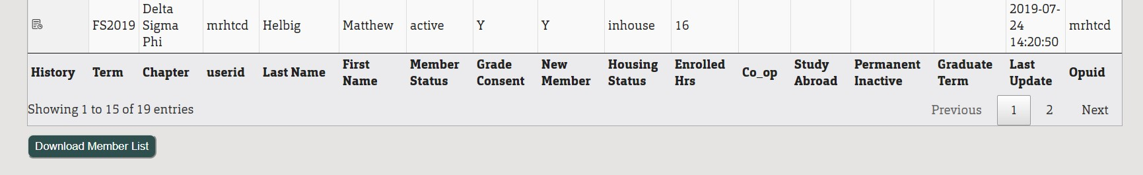
    - Click Download Report button and a csv file will download
- Individual Grade Report
  - Select appropriate Term and Chapter from the drop down boxes
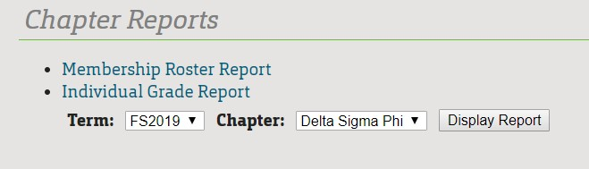
  - Click on Display Report
  - A table will appear on screen
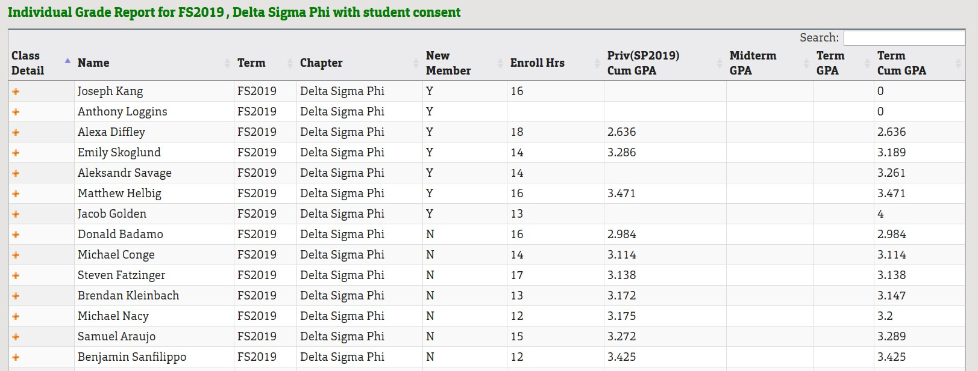
  - You can then search for a member based on any of the categories listed on the table
  - You can also click on the orange plus sign next to their name and a popup will appear with the student’s complete class schedule along with their grades for those classes ▪ At bottom of page click on Download Grade Report button for an exported file
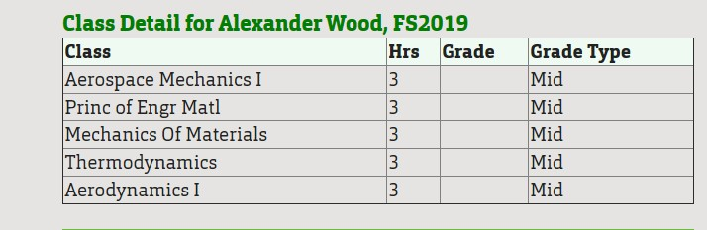

Member Reports
- Under construction

Process for New Member receiving bid and Returning Members receiving bid
- After admin completes bid the new member should receive an email o Following instructions are for the New Member to use to confirm bid
- Click the link in the email and sign in with your UM System login
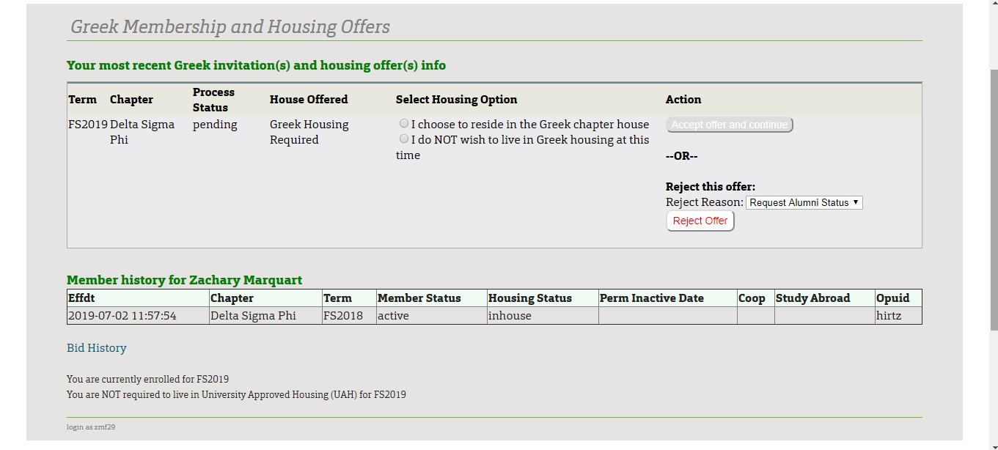
- You will see Term, Chapter, Process, Status, House Offered, Housing Option, and Action sections
- You will see if you are required to live in house or if it is optional. Two options to live in house or not live in house will be provided, choose the appropriate option o If you are required to live in house and choose to not live in house, you are forced to reject the bid
- Click Accept or Reject
- You will receive a pop-up message confirming housing status and will need to confirm the option again
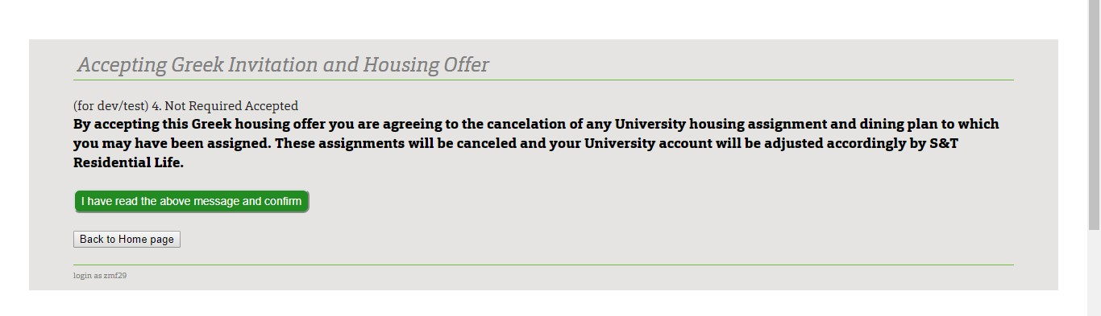
- A new page will populate with the Greek Grade Release Terms, read and you can choose to Consent or Not Consent, then click Continue
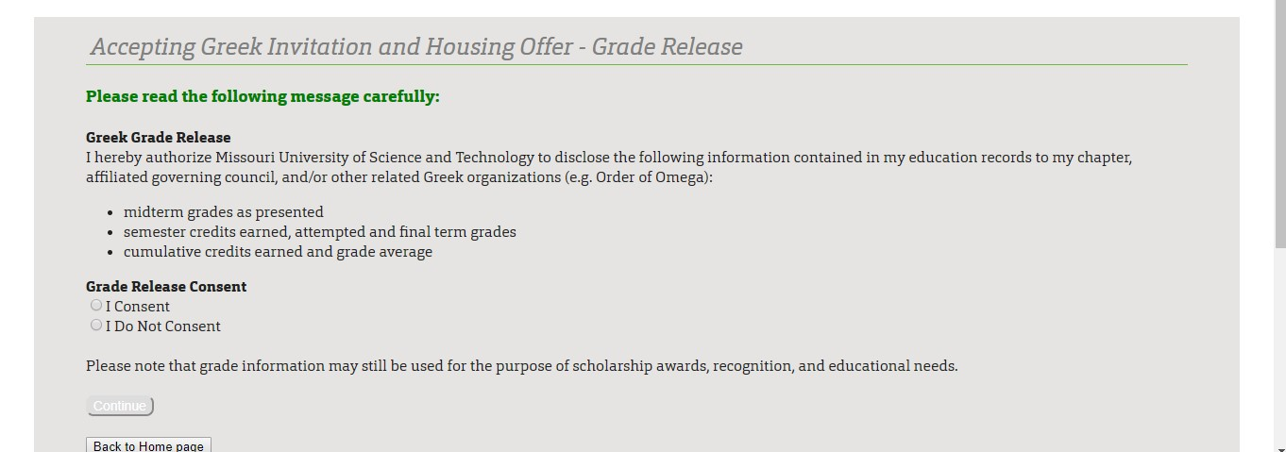
- The Student Org Policy about hazing will then populate and you will have to read and agree to the Anti-Hazing Policy Acknowledgement, click Continue o Anti-Hazing Policy is required, but the Greek Grade Release is not required
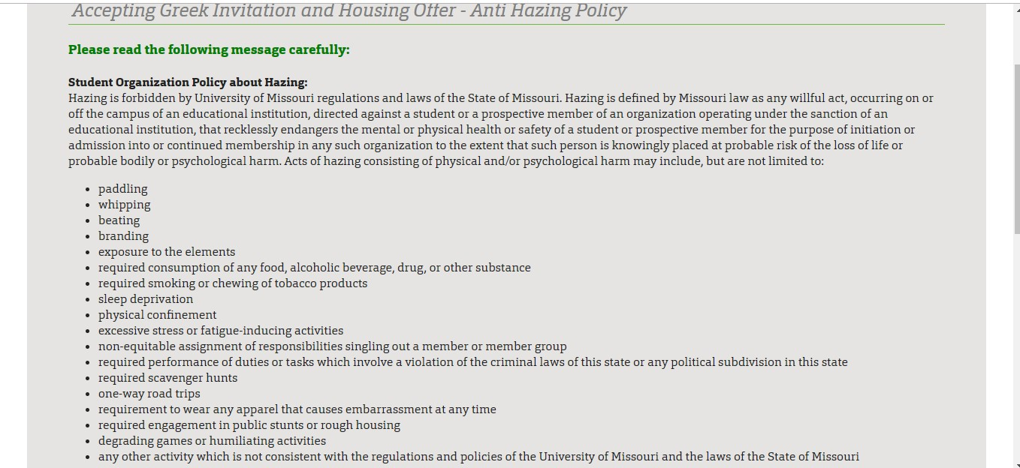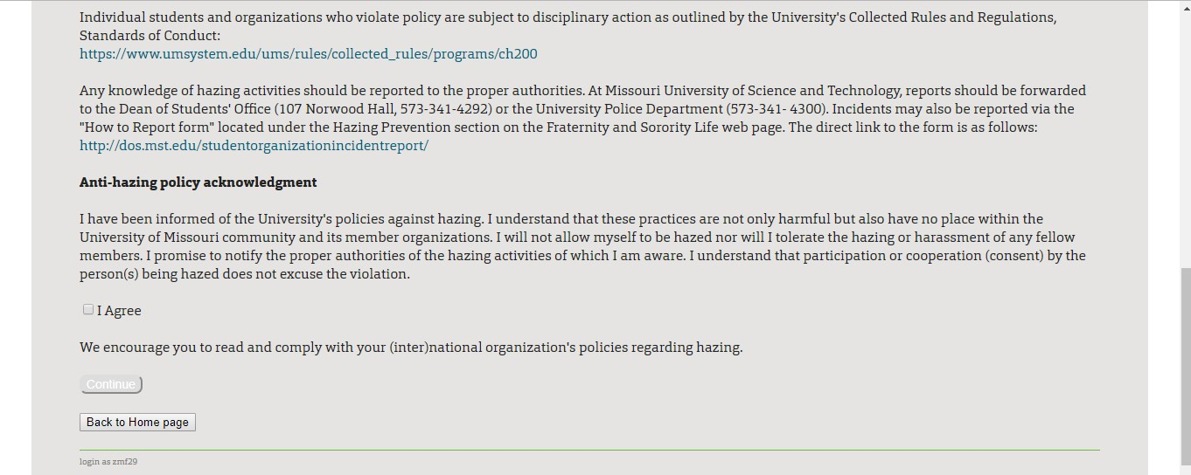
- Lastly the Standard of Conduct will populate, read, and click I Agree, then click Continue
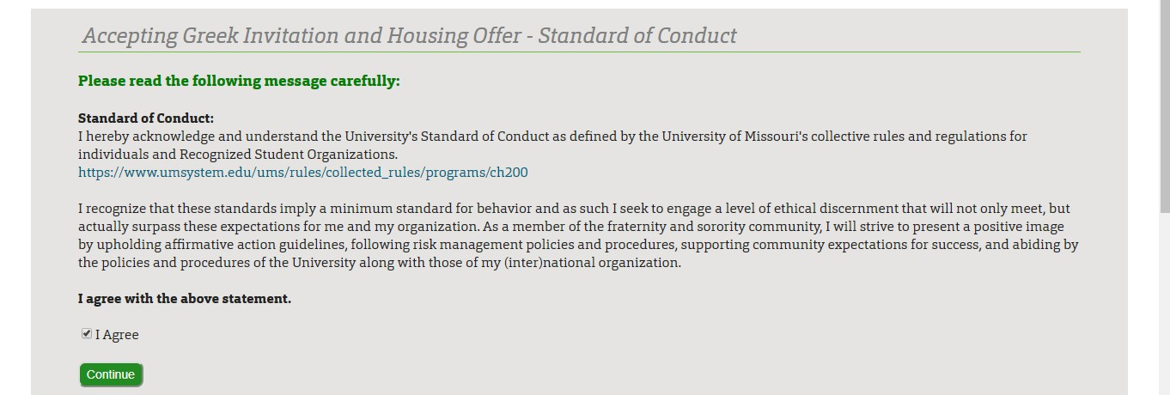
- Confirm bid one last time by reviewing the Term, Chapter, and Housing Option then click Confirm the Offer
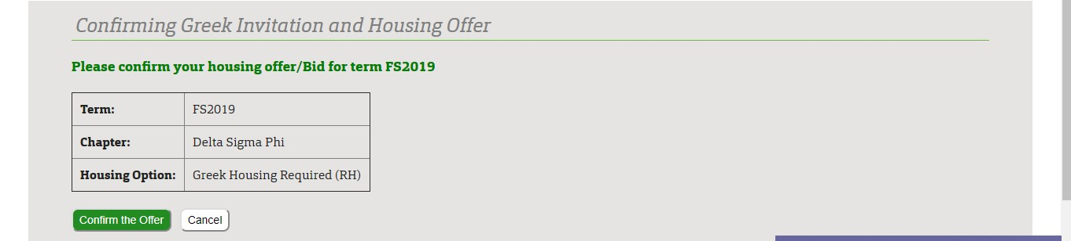
- Once finished, you should receive a confirmation email of Greek bid with attachment of all policies
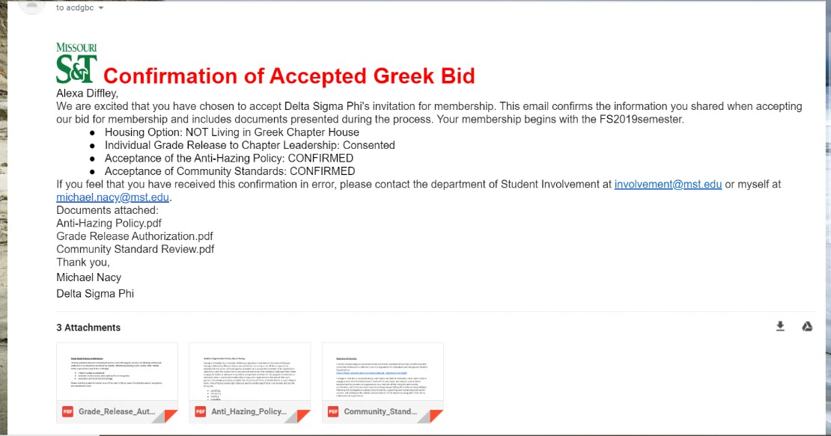
- If you declined the bid, you will be sent to a confirmation page to confirm you are declining the bid, your chapter and yourself will receive confirmation of decline o If you accidentally declined your bid, please contact Alison Ayers

